

**Team Legend**

**2017**

**Team 04**

Table of Contents

**Team Introduction ………………………………………………………………………………...3**

**Share a Meal………………………………………………………………………………………...3**

**Meet the Team……………………………………………………………………………………....4**

**Marhababanu Chariwala……………………………………………………………………4**

**Ian Ferguson………………………………………………………………………………….4**

**Lucy Xing……………………………………………………………………………………..4**

**Mark Davydov………………………………………………………………………………..5**

**Vladimir Efimov……………………………………………………………………………...5**

**Project Development……………………………………………………………………………….5**

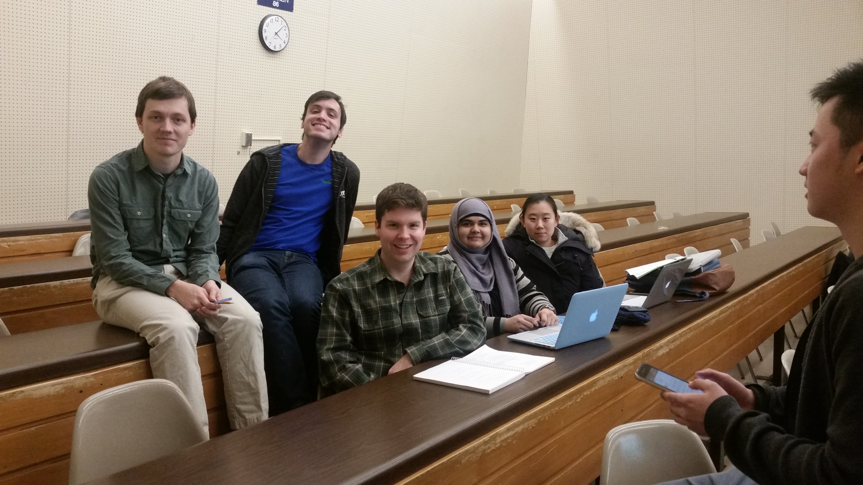Team Introduction

Our team is energetic, we work proactively on our tasks. We are academically strong, striving to always learn and excel in our studies. Next, we are strong communicators, and work well together towards common goals.

**Our goals for this semester:**

* Effectively and fairly delegate tasks within the team. Work should be spread evenly between all team members.
* Work together on tasks in person one to two hours a week.
* Develop a strong understanding of design patterns used in modern software.
* Contribute to an open source project, have our work count.
* Eat delicious food.

Share a Meal

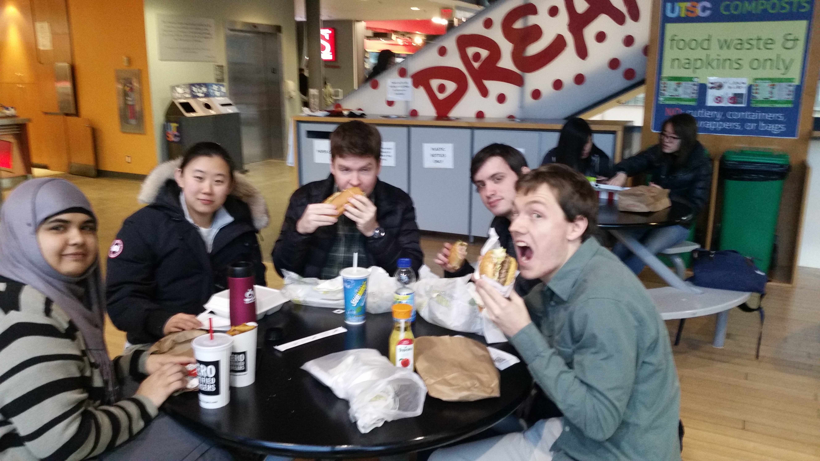

Meet the Team

**Marhababanu Chariwala**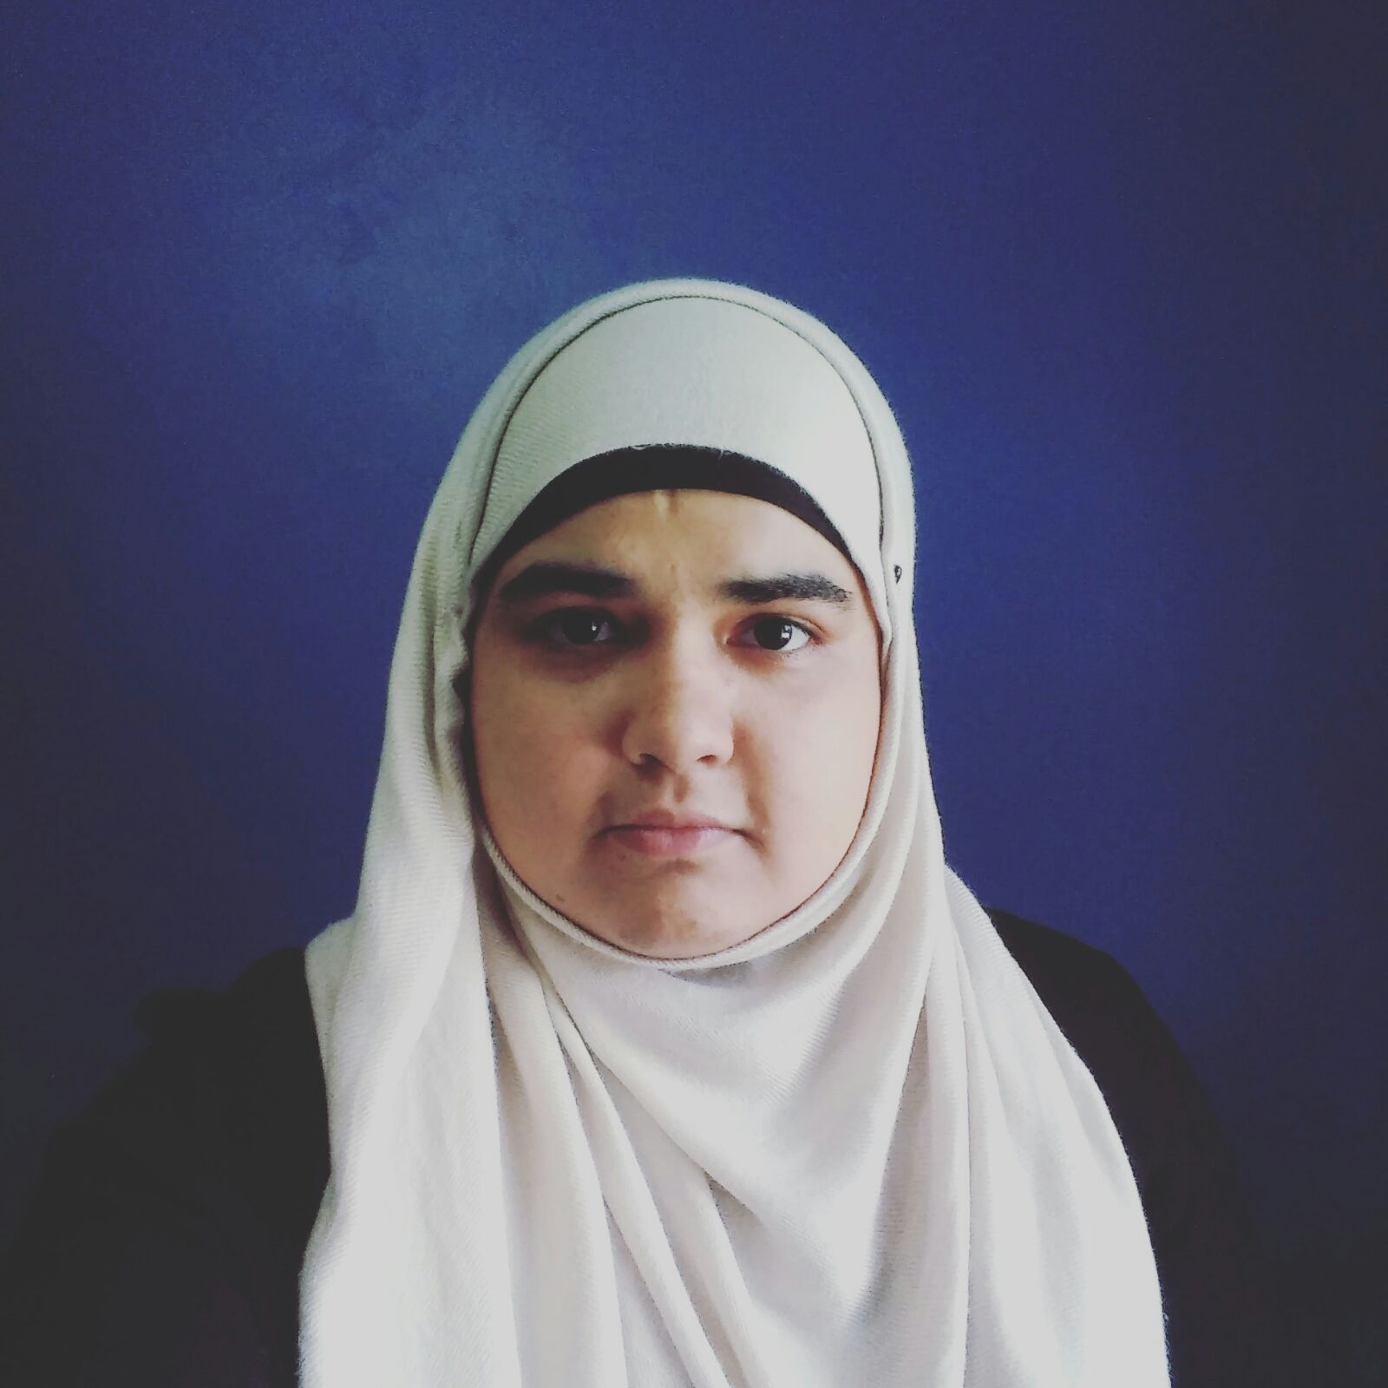 is pursuing bachelors in Computer Science at the University of Toronto at Scarborough specializing in Software Engineering. She enjoys challenges and critical thinking and can get creative with the solutions. She shows initiative in learning new materials. Through academic and co-op work term she has acquired advance knowledge and experience in programming using various languages like Python, Java and C. Her team was one of the finalists for Introduction to Software Engineering course project competition. In 2014, she started working for the French and Linguistics Centre at the UTSC as website management assistant. She worked as Junior Project Coordinator at Ministry of Ontario and assisted in training and testing of several different web based applications. During her last work term in 2016, she worked as Technical Analyst at CIBC's middleware operations, where she provided assistance in the maintenance of application servers and automation domain replication.

**Ian Ferguson** is a 4th year Computer Science student in the Software Engineering Specialist Stream, in his final semester at the University of Toronto; graduating in May 2017. Ian previously obtained a Bachelor of Commerce Degree in 2011 from the University of Ontario, Institute of Technology, and previously worked in the accounting field. As an accountant Ian worked for a financial markets technology company, where he was exposed to the software development process and worked closely with the

technology department in a budgeting capacity. There, Ian gained an appreciation for the challenges of software development and discovered a new passion in the process. In September 2014, Ian decided to pursue his passion and enrolled at the University of Toronto. When not engaged in his studies Ian can be found diving the waters of the St. Lawrence or Caribbean, or trying to get the perfect shot as an amateur photographer.

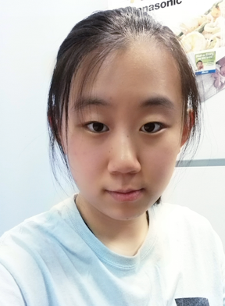**Lucy Xing** is currently a fourth year student at the University of Toronto Scarborough working towards a Specialist in Computer Science – Software Engineering Stream. In the past years at UTSC, she became proficient in various programming languages such as Python, Java, and C. Through previous projects and assignments, she also became familiar with SQL, OS161, Android SDK, and many others. For eight months from May 2015 to Dec 2015, she worked at CaseWare International Incorporated as a Test Developer where she developed automated test suites for both Desktop and Web APIs. During this time, she was introduced to performance testing and developed basic testing scenarios. She has also worked at the Toronto Public Library where she ensured shelf environment and provided technical support to patrons when needed. Lucy is looking forward to contribute to her team in CSCD01.

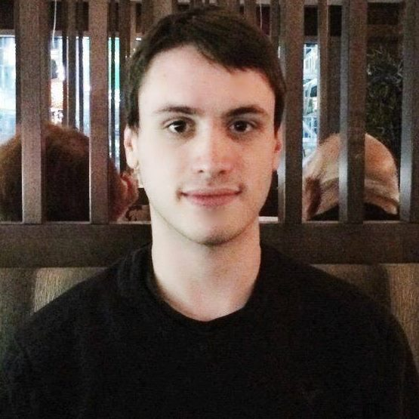

**Mark** **Davydov** is a 21 years old 3rd year Computer Science student who enjoys working on new and challenging problems.

Mark has had two work terms so far, one at IBM and one at Amazon. At IBM he worked on a web application that helped IBM employees handle certain tasks, such as booking hardware or a lab. At Amazon he worked on the Control Plane team for RDS Aurora, Amazon's cloud relational database service for high availability and reliability. His best strength is being able to adapt and learn very quickly. Mark is comfortable with the majority of commonly used technologies, including Git, SQL, Java, etc. He is looking forward to completing this project with his group, and he loves writing in third person.



**Vladimir Efimov** is a 3rd year student at University of Toronto Scarborough who is pursuing a degree in Computer Science. At about the age of twelve years old is when he discovered his passion in programming at a university summer camp. That is where he first learned the very basics of creating software, via dragging colourful code blocks to make a 2D maze game using Scratch. Once he enrolled in University of Toronto in 2013, he became instantly involved in the school's residence council, and joined a sport team. There was a balance he kept between studies, extracurriculars and wellbeing. During his time at the University, he landed co-op placements at CaseWare as a Test-Developer, and at University Health Network as a Java Developer. Currently Vladimir is a Teaching Assistant for the Computer Organization course. He is also the President of Quidditch and Vice President of Academics for AMACSS.

Project Development

Our team will work by using a task-based system where tasks have to be completed within a sprint:

* Each task will be tracked using Trello.
* Each sprint is two weeks long. This length of time is flexible given the circumstances.
* A sprint meeting is held just before the next sprint starts.
* The tasks are created, reviewed and assigned at reach spring meeting.
* The available developer hours of team member will be determined at each sprint meeting.
* Each task has a cost attached to it in developer hours.
* Communication shall be kept using WhatsApp.
* Google Docs will be used when collaborating on a document.